**C-DAC Mumbai**

**Lab Assignment: 2**

**Problem 1**: Grade Evaluation System

**Problem Statement:**

Write a Java program that calculates the average marks of a student and determines the grade based on the

following criteria:

**Grade A:** Average marks ≥ 90

**Grade B**: Average marks between 70 and 89

**Grade C**: Average marks between 50 and 69

**Grade D**: Average marks between 30 and 49

**Fail**: Average marks < 30

**Predefined Values (Try with different values as well):**

● Marks in Maths = 80

● Marks in Science = 85

● Marks in History = 90

**Expected Output:**

Average Marks: 85

Grade: B

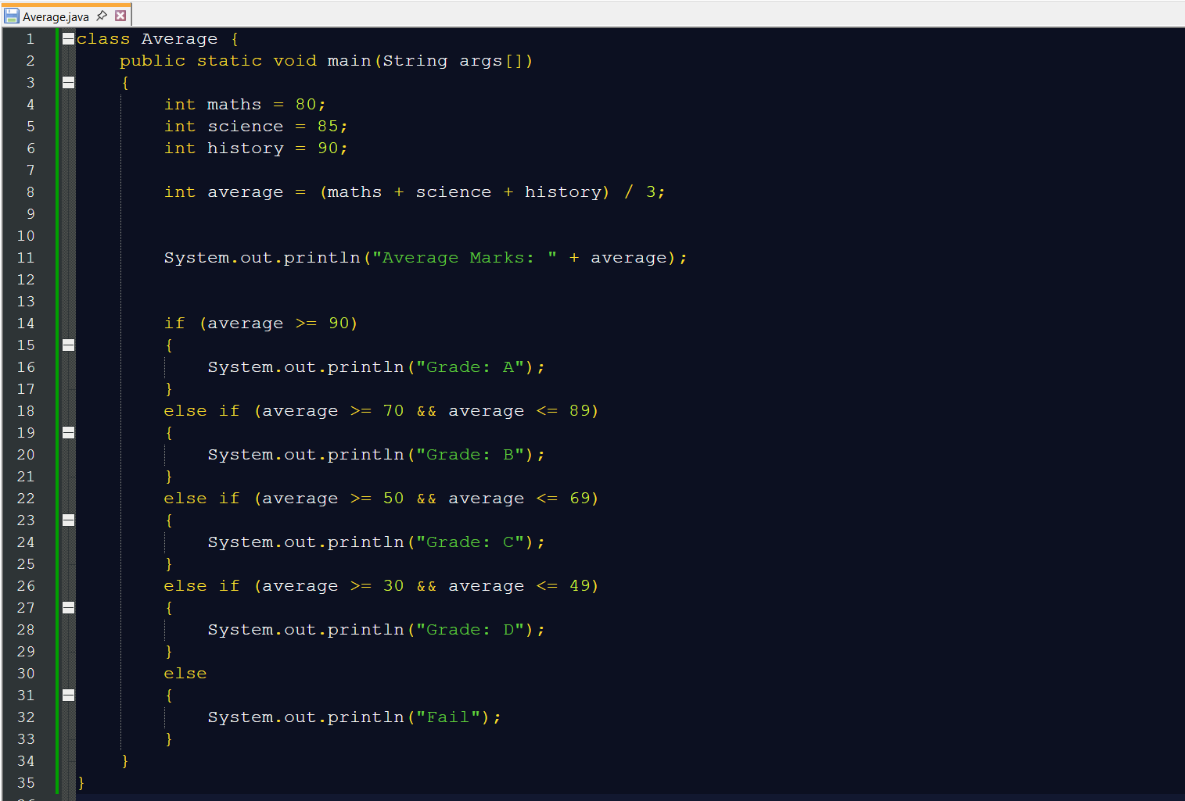

**Output:**

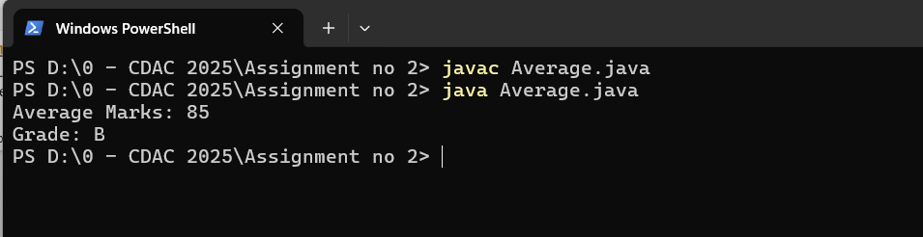

**Problem 2**: Leap Year

**Problem Statement:**

Write a Java program that checks whether the year is a leap year or not. A year is a leap year if:

It is divisible by 4, but not divisible by 100, orIt is divisible by 400.

**Predefined Value (Try with different values as well):**

● Year = 2024

● Year = 1900

**Expected Output:**

2024 is a leap year.

1900 is not a leap year.

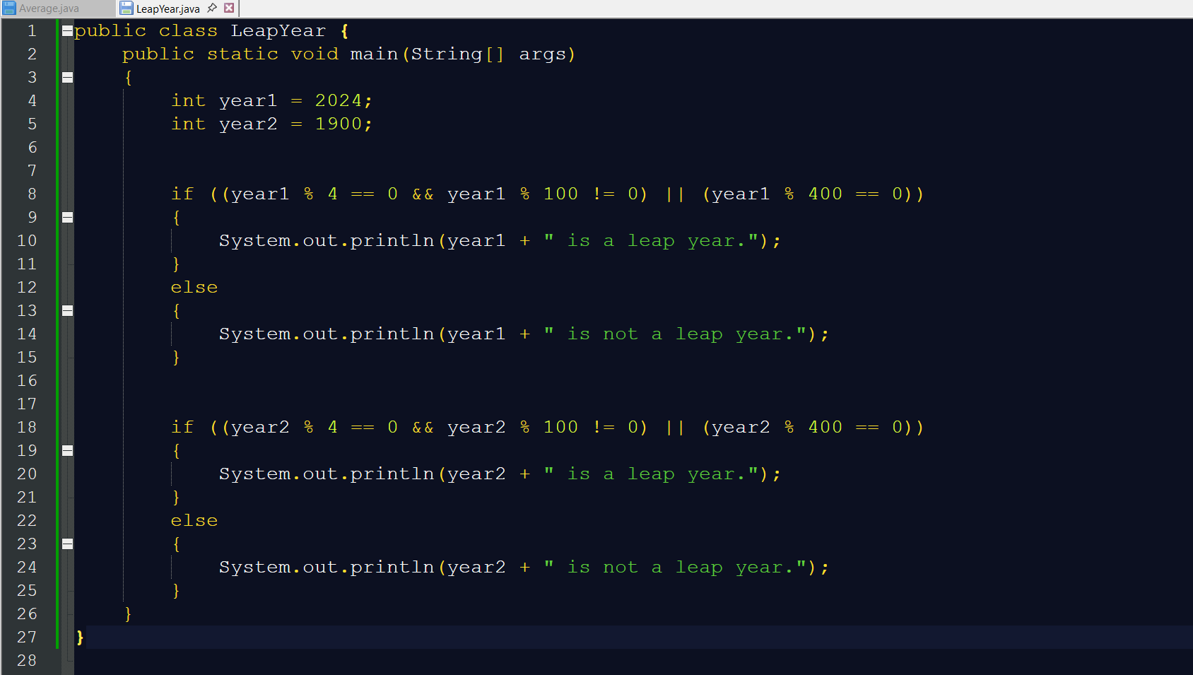

**Output:**

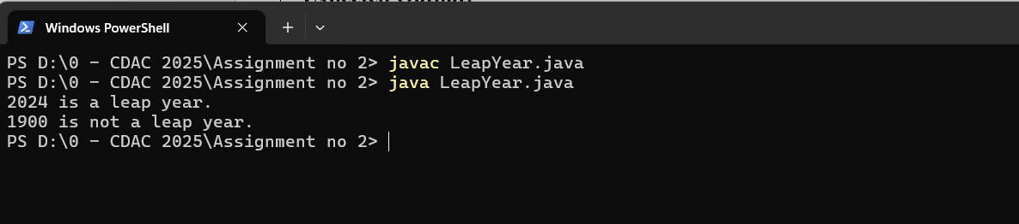

**Problem 3**: Days of the Week

**Problem Statement:**

Write a Java program that takes an integer between 1 and 7 and prints the corresponding day of the week

using a switch-case statement. If the input is outside the range of 1 to 7, the program should display

"Invalid day number".

**Predefined Value:**

Day number = 3

**Expected Output:**

The day is Wednesday.

